
S
N

De La Salle University • College of Computer Studies

General Report Formatting Guidelines

When submitting any written documents in this course, the following guidelines must be adhered to. Nonadherence will merit deductions.

Report Body

Fonts and Indentation

Use Arial 10 points, single line spacing, and 0.5-inch top, bottom, left, and right margins on standard (8.5x11”) bond paper. (You may use recycled 8.5X11” bond paper for proposals and preliminary reports.) Insert a blank line before each paragraph; do not indent the first line. Use the American Psychological Association’s (APA) style for references. Do not print back-to-back. Place page numbers on the lower right corner of each page.

Use Arial 11 points, bold for section headings and Arial 10 points, bold for subsection headings (see above). If there is no way you can omit subsubsection headings, use Arial 10 points, italicized, for them. Insert two blank lines before section headings, and one blank line before subsection (and subsubsection) headings. All headings will be flushed to the left margin. Do not number the headings/subheadings.

Figures and Tables

If you use figures (e.g., graphs), center them between the left and right margins in portrait orientation, and place captions below them. Preface each caption with “Figure” followed by the figure number and a period (all in Arial 10 points, bold). Figures should be resized to a height of exactly three inches (3”), aspect ratio locked. However, if the figure is a screenshot of a system (e.g., an Eclipse plug-in for refactoring), the screenshot should be resized to a height of exactly four inches (4”), aspect ratio locked.

If you have tables, center them between the left and right margins in portrait orientation, and place captions above them. Preface each caption with “Table” followed by the table number and a period (all in Arial 10 points, bold). The contents of the table should be in Arial 9 points.

Be sure to explain all figures and tables. Place figures and tables as close as possible to the point in the text where they are referred to for the first time.

Report Header

Report Title and Short Identifier

The header on your paper’s first page should be as above, but with the title of your report replacing “General Report Formatting Guidelines”.

In the box on the upper right corner of the header, write your section and your number in class (for submissions by an individual) or your group number (for submissions by a group). Get these numbers from the professor (or from the URL below) on the second week of classes.

Submission Details

Below the title of your report write the following submission details:

Name (last name first) : <your_name>
Section : <your_section>
E-mail address : <your_e-mail_address>
Date of Submission : <actual_date_of_submission>
Time of Submission : <actual_time_of_submission>

You may write the actual date and time of submission by hand.

If you are submitting a group report: Write the name of the group leader first, followed by the names of the members in alphabetical order. Write your group number next to your section (e.g., S17 G1). Write only the e-mail address of the group leader (or whoever the group designates to regularly check for any e-mails from the professor).

Table of Contents

If your document is longer than 5 pages, begin the actual report on the second page. On the first page, place a detailed table of contents (with the page numbers of the sections and subsections specified) below the header and submission details prescribed above. Use Arial 10 points.

Other Instructions

Staple the sheets together or place them unstapled inside a clear, short, plastic envelope. Stapling the sheets together is preferred, but only if the sheets can be stapled together completely and cleanly using a single staple wire. If this is not possible (e.g., if the document is too thick for your stapler), place the sheets unstapled inside a clear, short, plastic envelope in the following manner:
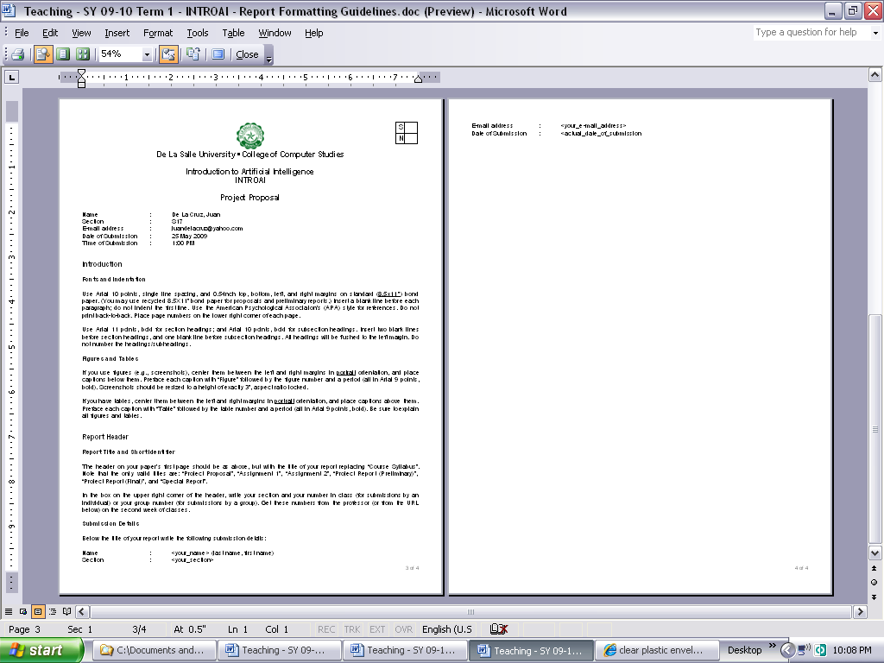

Burn source code listings and executables on a CD containing a readme.txt of instructions on how to install and run the executable as well as the source code. Print the submission details on a 3x3-inch nicely cut white piece of paper and insert the paper in the CD jacket.

For students of Dr. Raymund Sison

